Devon Rogers

ECE/BME 4784

Phase 1

a) The cell membrane can be modeled as an electrical circuit appearing as follows:  
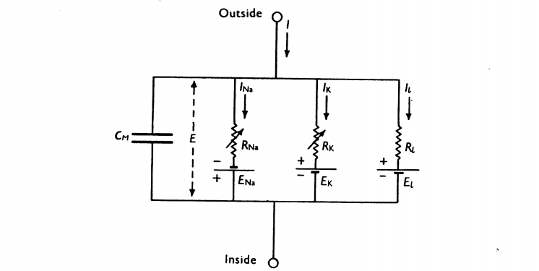

**Figure 1.** Hodgkin & Huxley electrical Model for a cell membrane.

**Cm** represents the membrane capacitance due to the buildup of charges on either side of the phospholipid bilayer (since virtually no charges exists in this layer). Although the membrane may twist and turn, if a unit length is observed, then we have 2 areas of charge in parallel to each other with some dielectric in between, and can therefore model this effect as a parallel-plate capacitor. **E** or **Vm** in this model represents the membrane voltage across this capacitor. **EK** and **ENa** represent the Nernst potential for these two ions, at which there will be no net flow of the ion through the membrane. This potential is due to diffusion current (from the concentration gradient) and drift current (due to the electric field). These potentials can be modeled as batteries. Conductance **gK**, **gNa**, and **gL** arise due to the resistance associated with the ions going through the potassium channels, sodium channels, and leaking through the pores. In the Hodgkin & Huxley model, the transport of chlorine ions is represented in the leakage branch. The variable conductances in the model represent voltage-dependant channels, whereas the others represent resting channels. If a channel were to be closed, it would have a conductance of 0. Open channels have a high conductance value. The motion of these ions across this membrane causes a current **I**.

b) My GitHub repository can be found at: <https://github.com/devonrog/ECE_BMEDProjectPhase1>

c)